Lab Report 5: Lab7 Bash File

—-----------------------------------

Run Commands

—----------------------

```

ssh cs15lwi23(last three characters of username)@ieng6.ucsd.edu

bash runLab7.sh

```

runLab7.sh

—----------------------

```

git clone git@github.com:RyanC1681/lab7.git

javac \*.java

javac -cp .:lib/hamcrest-core-1.3.jar:lib/junit-4.13.2.jar \*.java

java -cp .:lib/hamcrest-core-1.3.jar:lib/junit-4.13.2.jar org.junit.runner.JUnitCore TestListExamples

vim ListExamples.java

i (vim insertion)

change "index1" to "index2" on line 43 in the last while loop

:wq (vim save and close)

javac -cp .:lib/hamcrest-core-1.3.jar:lib/junit-4.13.2.jar \*.java

java -cp .:lib/hamcrest-core-1.3.jar:lib/junit-4.13.2.jar org.junit.runner.JUnitCore

git add ListExamples.java

git commit -m "fixed ListExamples bug"

git push origin main

```

Result ListExamples.java

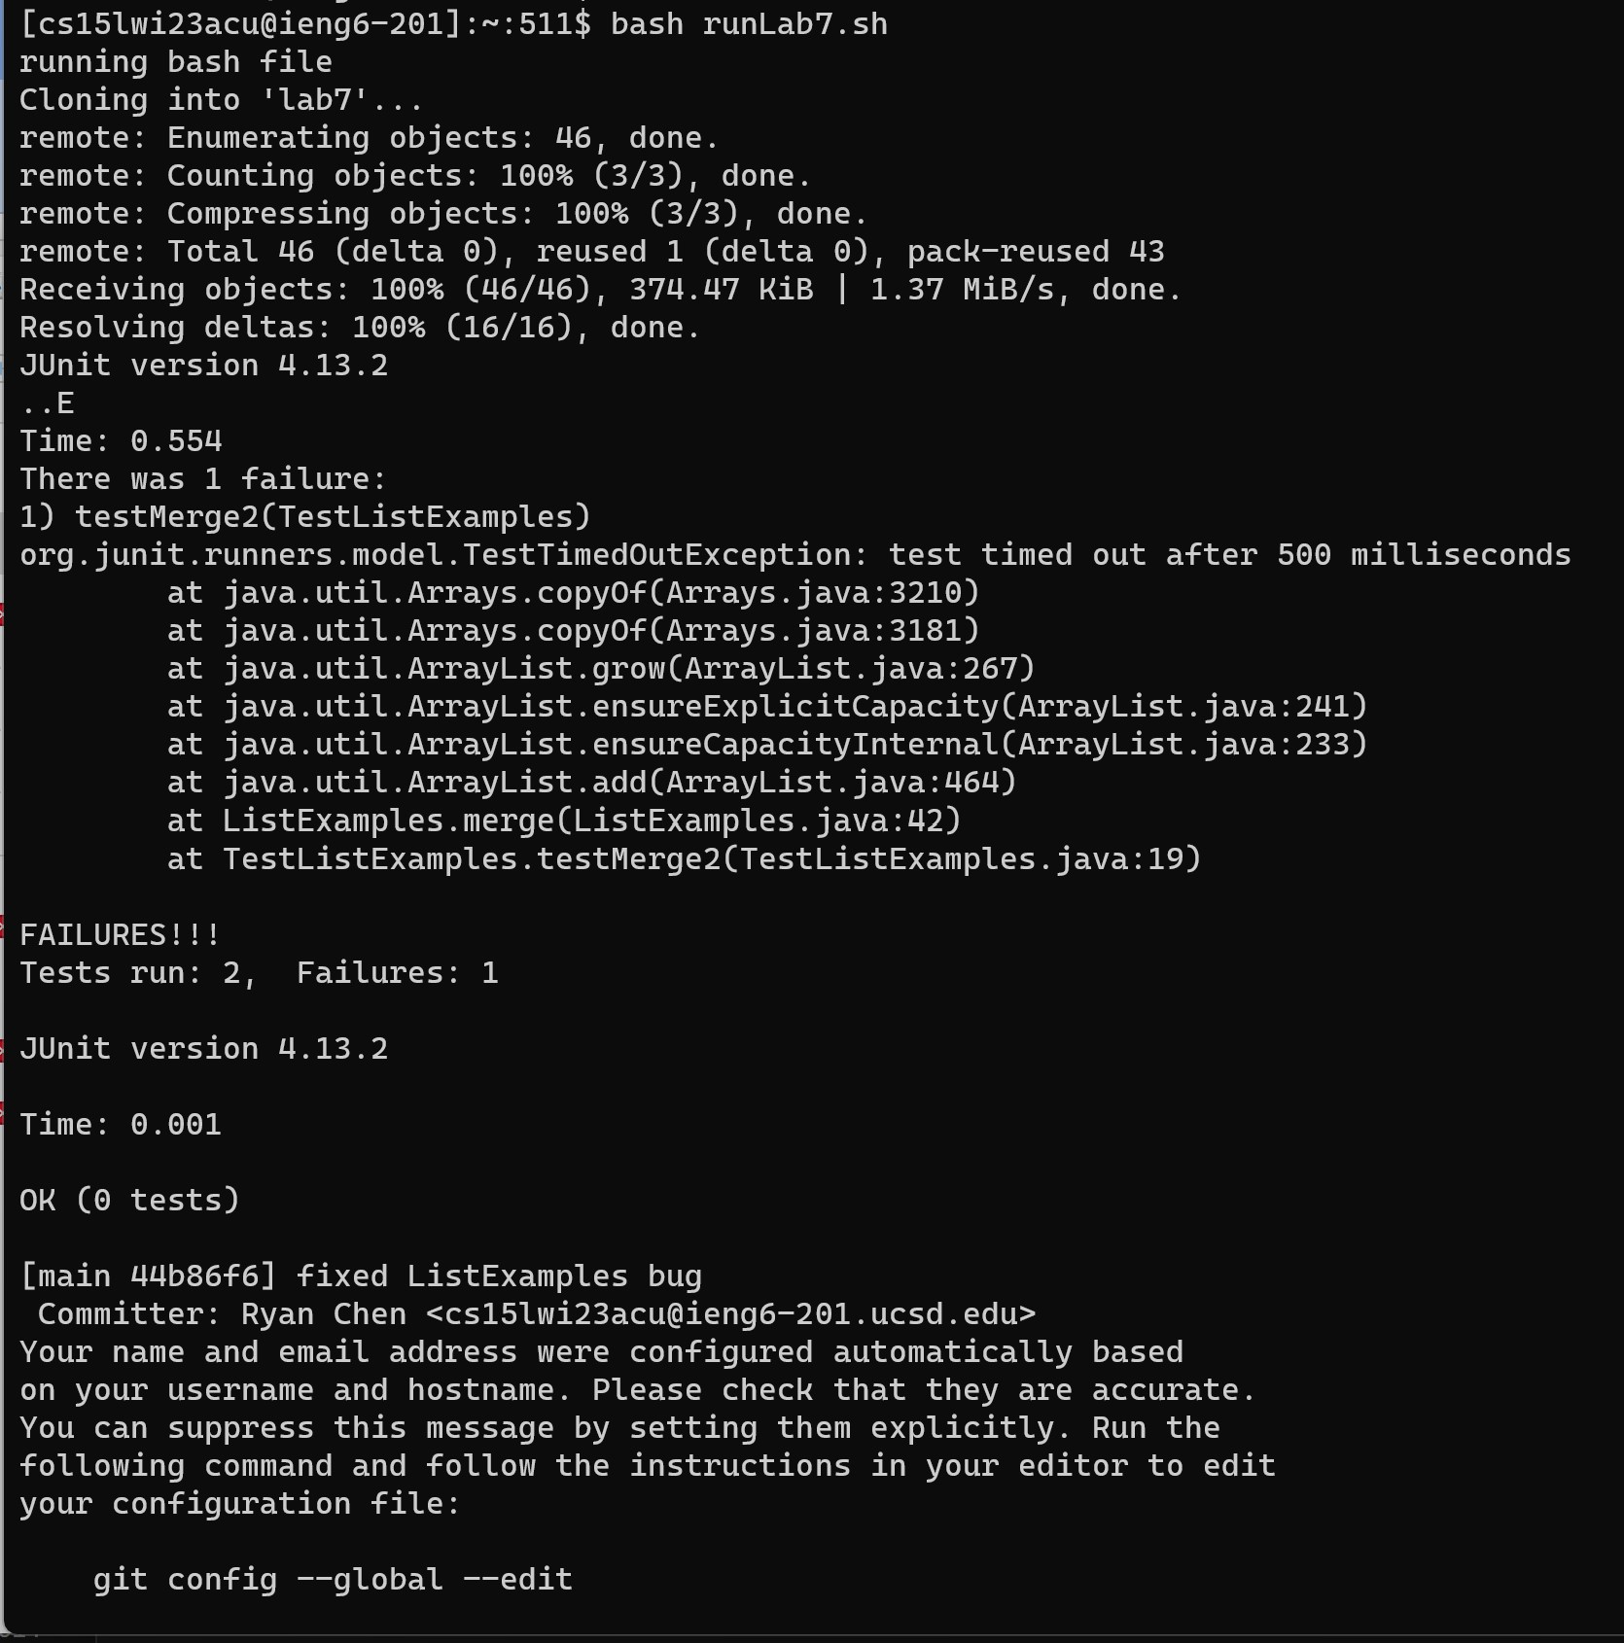

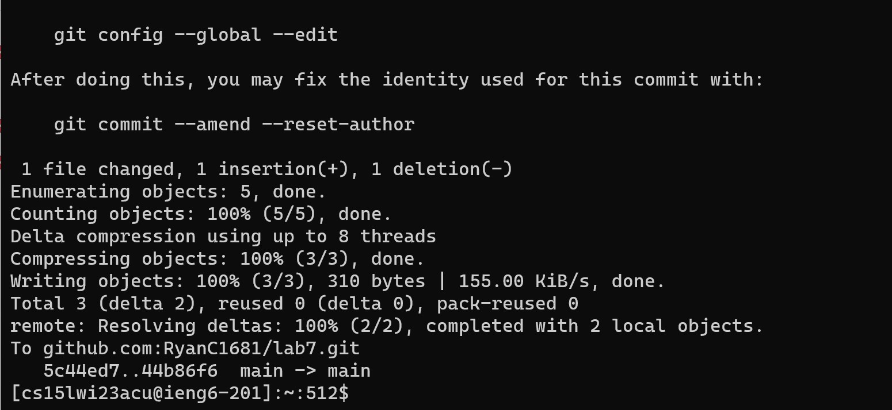

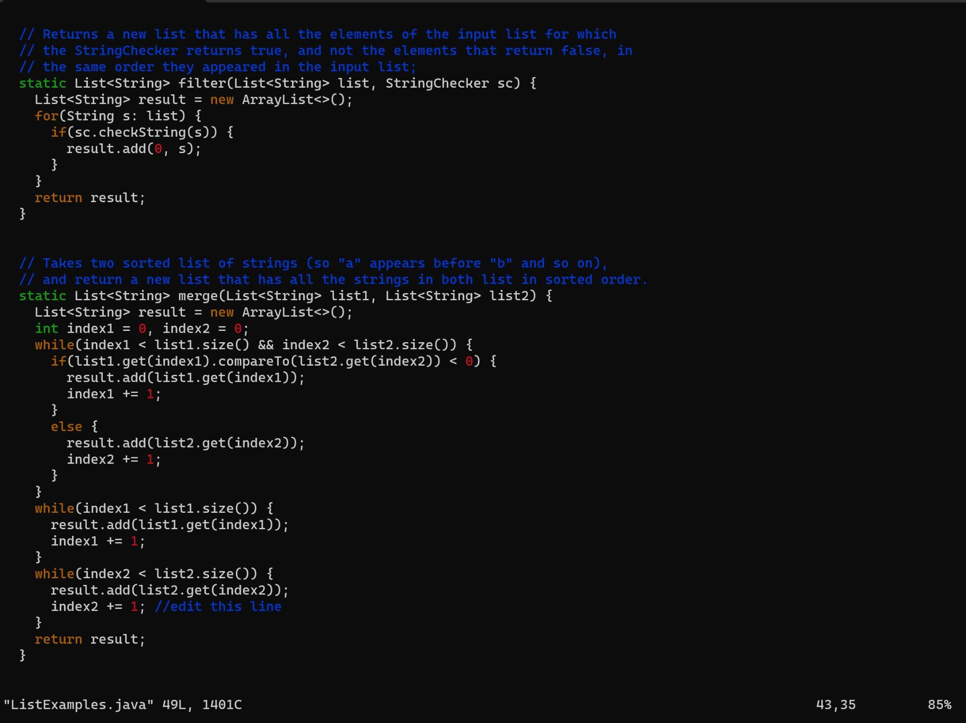

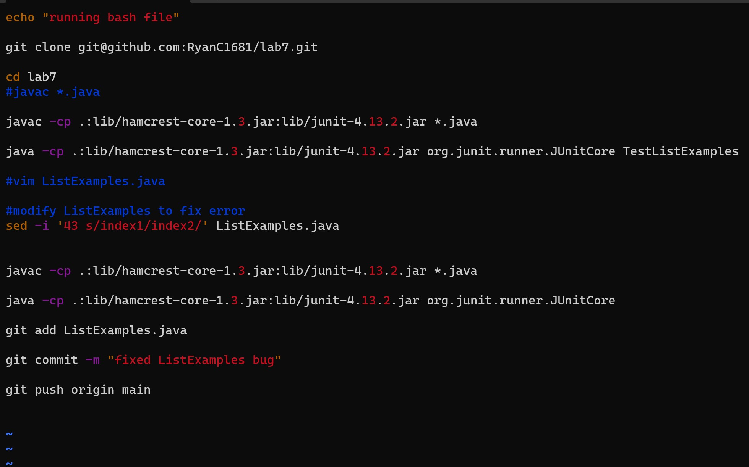

First test needs to fail:

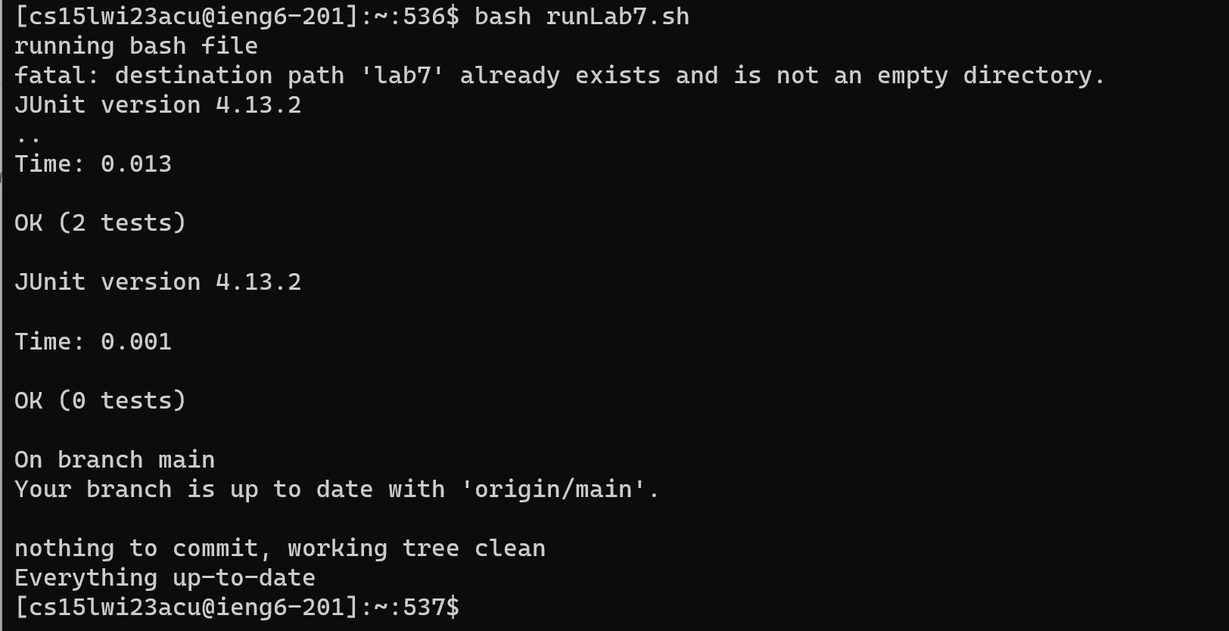

1. ssh cs15lwi23(last three characters of username)@ieng6.ucsd.edu

2. git clone git@github.com:RyanC1681/lab7.git

3. javac \*.java

4. javac -cp .:lib/hamcrest-core-1.3.jar:lib/junit-4.13.2.jar \*.java

5. java -cp .:lib/hamcrest-core-1.3.jar:lib/junit-4.13.2.jar org.junit.runner.JUnitCore TestListExamples

6. vim ListExamples.java

i (vim insertion)

change "index1" to "index2" on line 43 in the last while loop

:wq (vim save and close)

7. javac -cp .:lib/hamcrest-core-1.3.jar:lib/junit-4.13.2.jar \*.java

8. java -cp .:lib/hamcrest-core-1.3.jar:lib/junit-4.13.2.jar org.junit.runner.JUnitCore

9. git add ListExamples.java

10. git commit -m "fixed ListExamples bug"

11. git push origin main